

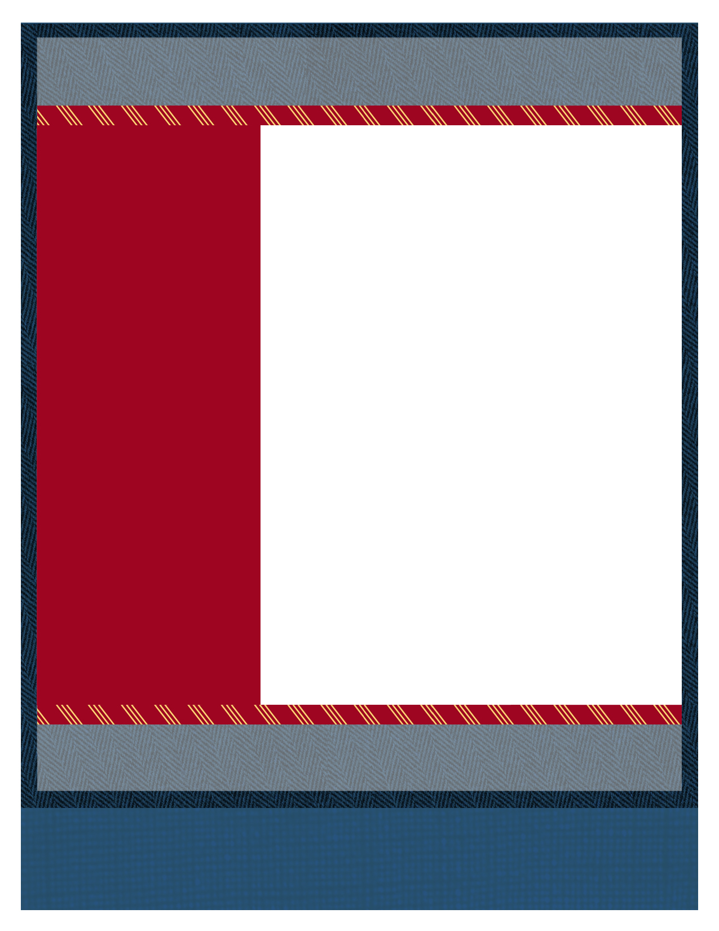
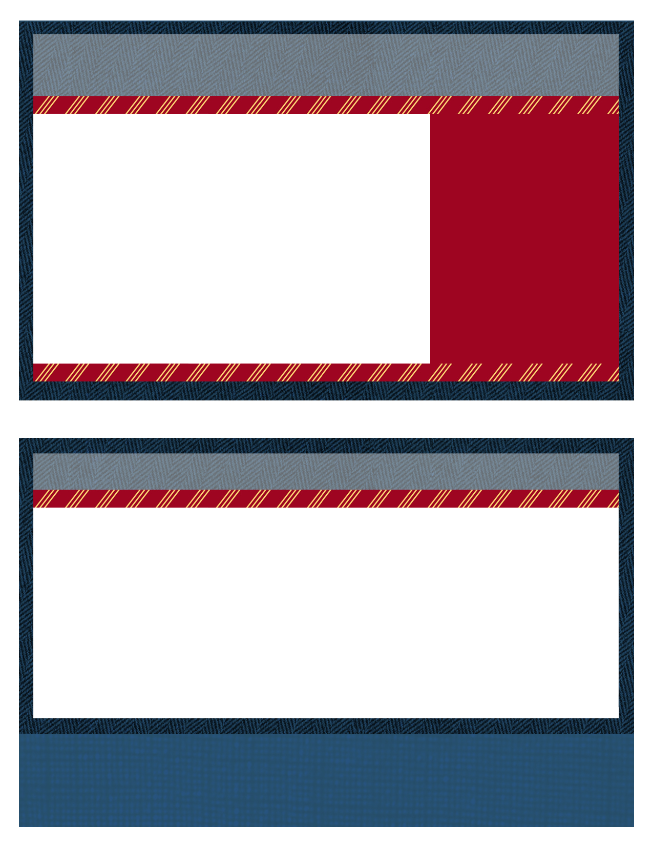

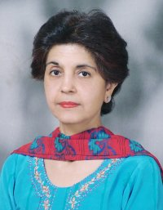

Dr Sarita Bajaj,
President, SAFES.

July /2013

The SAFES Collaborative
South Asian Endocrinology is Going Global.

Volume 1 issue 1

SAFES Editorial Board
Editor: Dr Unnikrishnan AG
Secretary: Dr Rakesh Sahay
Patron: Dr Chandrika SAFES

Design and Layout
Nadia Jajja
Ramsha Zaheer
EDITORIAL BOARD

the official bulletin of the south Asian federation of endocrine societies

It is an honor to be at the helm of the affairs as President of the newly formed South Asian Federation of Endocrine Societies (SAFES) having taken on the mantle in Colombo in January, 2013. It is a giant step for Endocrine Society of India.
Before beginning I must convey me deep regret on the sudden and tragic demise of Dr Fatema Jawed’s husband after a brief illness. May his soul rest in peace. Our heartfelt sympathies to the bereaved family members. Dr Fatema Jawed has an instrumental role to play in SAFES.
The regional basis of SAFES formed by five national professional organizations of India, Pakistan, Sri Lanka, Bangladesh and Nepal should be instrumental in development of strategies and their implementation regarding endocrine problems specific to this region.
As the President of SAFES, I believe that continued support and faith of our National Endocrine Societies would be the key leading this federation into future success. Your feedback will be most welcome to ensure the security and strength of this organization as it moves forwards in leaps and bounds.

Presidential
- Dr Sarita Bajaj, President, SAFES

SAFESOUND
Paradoxical as it sounds, endocrinology is as common as it is rare. For example, are not diabetes, hypothyroidism, obesity and osteoporosis the commonest among the common diseases? And, isn’t it true that congenital adrenal hyperplasia, androgen insensitivity and acromegaly are rare occurrences?

In contrast to the common occurrence of Endocrine Diseases, Endocrinologists are truly rare. In terms of income, an endocrinologist’s salary is comparable to that of an internal medicine specialist. For, like internal medicine, endocrinology had no therapeutic intervention to call its own.

Why then do doctors choose to be endocrinologists? There are many theories- need for a higher degree, need to specialize, an interest in the science of hormones and of course- a perception (occasionally proved wrong) that the cutting edge of the intellect is sharper than the sharpest of scalpels.

Whatever the reason, endocrinologists have a reason to rejoice. Never before has medical literature been filled with exciting therapies in endocrinology. Whether it is diabetes. obesity or osteoporosis – new treatments are jostling for some space on the horizon, and changing patients’ lives for the better worldwide. And South Asia, arguably a growing economic powerhouse- is the ideal place for the next era of cutting-edge endocrine care, research and collaboration.
Provided of course, that we endocrinologists in South Asia seize this moment as our own, and unleash the potential within it. And that is truly the idea of SAFES. An international collaborative with a purpose. Of advancing endocrinology. And changing patients’ lives for the better.

Editorial

South Asian Endocrinology- Seizing the Moment.
-Dr Unnikrishnan AG

July /2013

Volume 1 issue 1

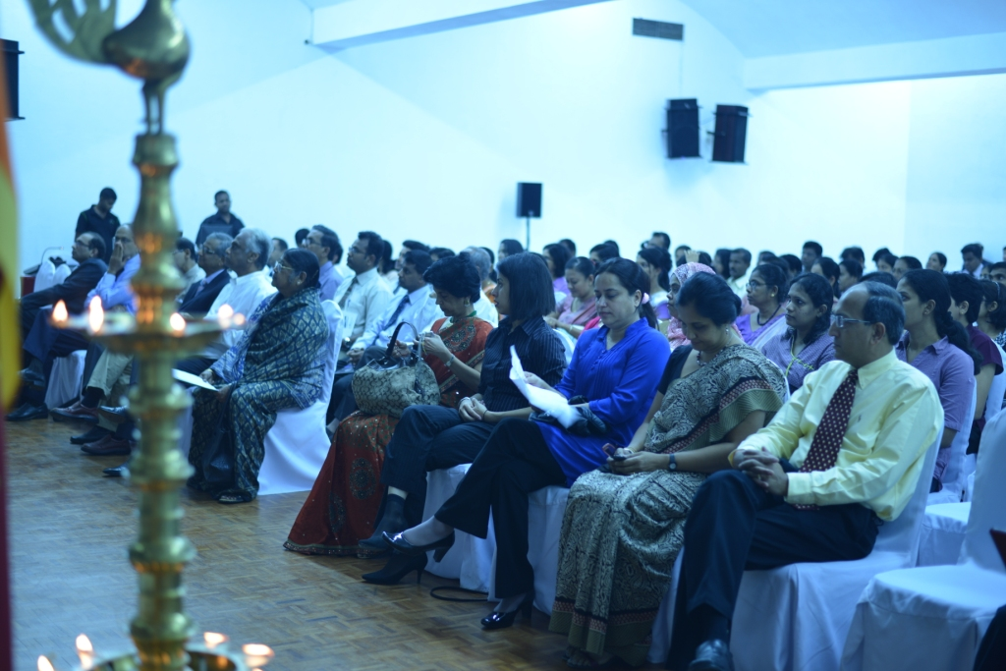

Delete text and place photo here.

The Endocrine Society of Sri Lanka (ESSL) and the South Asian Federation of Endocrine Societies (SAFES) jointly organized an academic programme - Advanced Course in Diabetes 2013 on 18th January 2013 at Sri Lanka Foundation Institute, Colombo. This was the first program of the SAFES. The faculty included 17 experts from the SAFES region- Dr. S Chowdhury, Dr. Sarita Bajaj, Dr. Rakesh Sahay, Dr. Sanjay Kalra, Prof. Thilak Weeraratne, Dr. Manilka Sumantilleke, Dr. Noel Somasundaram, Dr. Henry Rajaratnam, Dr. Prasad Katulanda, Prof. Mandika Wijeyaratne, Prof. Chandrika Wijeyaratne, Dr. Syed Abbas Raza, Prof. Shamya de Silva, Dr. Sajith Siymabalapitiya, Dr. Charles Antonypillai, Dr. Uditha Bulugahapitiya, Prof. Sisira Siribaddana. The participants numbering more than 250 were from a wide spectrum of medical professionals and para medical staff. The ESSL launched a clinical guideline named Diabetes Mellitus - Glucose Control on that day and the first copy was given to the President of SAFES Dr Sarita Bajaj by the president of ESSL Dr Noel Somasundaram.

SAFES CONDUCTS ACADEMIC
PROGRAM IN SRI LANKA
“RESEARCH IS THE CALL OF THE DAY”- Dr Sarita Bajaj, President, SAFES

at Colombo,. more than 250 delegates attended safes academic course
Write captions for the selected photos.

Volume 1 issue 1

July /2013

Important research from SAARC Countries this quarter

1. Hari Kumar KV, Misra A. Endocrine and diabetes research from SAARC countries. Indian J Endocr Metab (Accepted, In Press)
2. Begum F, Ahmed CM, Afroz S et al. Lean body mass based levothyroxine replacement in young athyreotic patients with differentiated carcinoma of thyroid. Indian J Endocr Metab 2013;17:254-9.
3. Khan AA. Diabetes awareness through religious leaders. Indian J Endocr Metab 2013;17:178-9.

The Indian subcontinent or the south Asian region with its eight nations namely, Afghanistan, Bangladesh, Bhutan, India, Maldives, Nepal, Pakistan, and Sri Lanka constitute the SAARC (South Asian Association for Regional Cooperation). The research output from SAARC countries in the field of endocrinology and diabetes is growing at a rapid pace (1). In this first quarterly report, we bring the important research articles pertaining to endocrinology from all SAARC countries published in the Indian biomedical journals (See references listed adjacent to article) . The first study from Bangladesh was about the basis of the levothyroxine dose after thyroidectomy (2). In this report, the authors calculated thyroxine dose based on the lean body mass in patients after thyroidectomy in low risk differentiated carcinoma. The dosing pattern was better with benefits on cardiac activity and quality of life with reduced hyperthyroid symptoms. Awareness aspect of diabetes is brought into consideration by a letter to editor from Bangladesh, the first SAARC country to take such a major step in diabetes prevention (3). All the religious leaders were involved to increase the public awareness about diabetes and its preventive measures. The intervention involved the Imams of mosques, Priests in churches and temples for spreading the awareness during prayers. The program is now being implemented as the policy of the Bangladesh government. Dr Khan pioneered this model program not only for diabetes but also for non-communicable diseases.

Endocrine Research – A SAARC perspective
- DR KVS HArikumar & DR Altamash S

Recently, our SAFES Team got together at a meeting and the ideas for a South Asian Collaborative Was Crystallized.

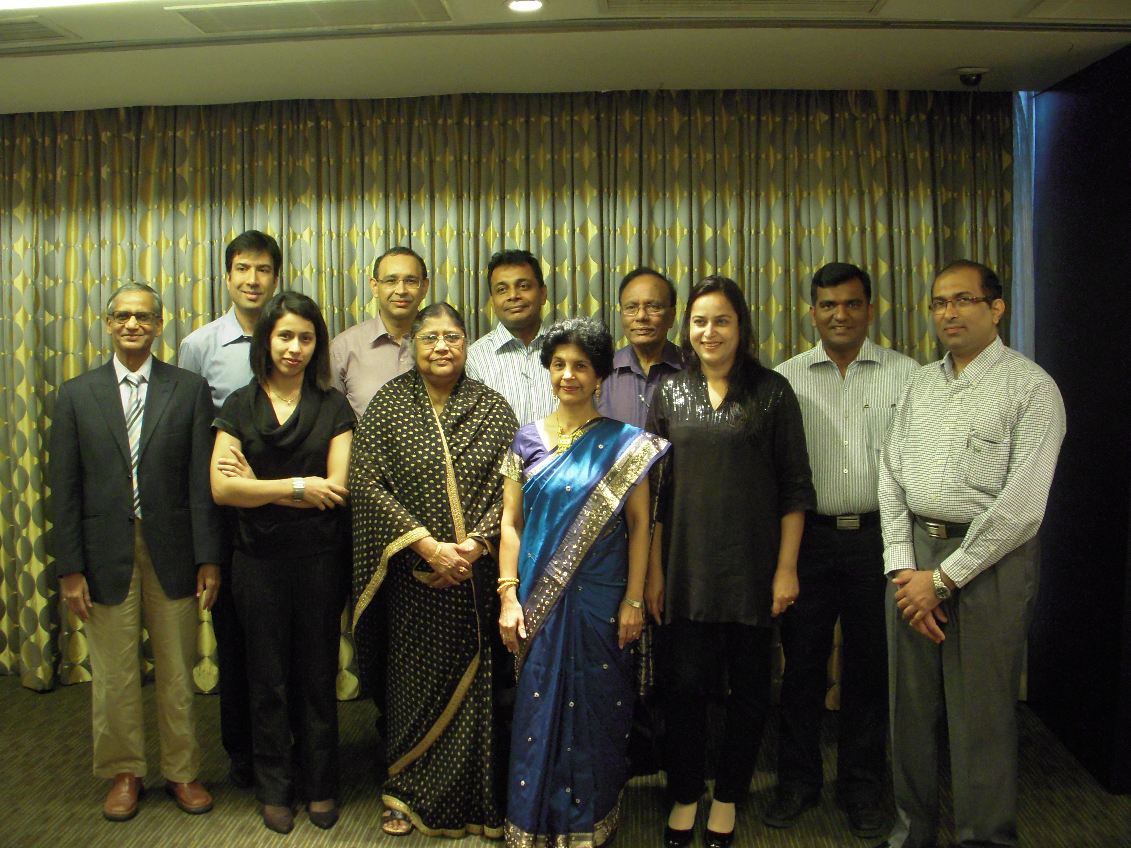
got an interesting photo of Endocrine Teamwork in your area?
send it to the safes newsletter team

“Hormones, like humans, love to work in a team”- Sanjay Kalra, Vice President, SAFES
SAFES EDITORIAL OFFICE-

Dr AG Unnikrishnan, MD, DM
Editor, SAFES Bulletin,
CEO and Chief Endocrinologist
Chellaram Diabetes Institute,
Bavdhan, Pune – 411021, India
e-mail - uag@cdi.org.in

SAFES

Presents

International Endocrine Update

17th and 18th August 2013
in Hyderabad, India

Be there.

Organized by Dr RK Sahay
Contact- sahayrk@gmail.com

Posted to:

The SAFES Mandate
- State of the art scientific programs
- Introduction of an e-journal or e-newsletter
- Preparation of south Asian consensus statements
- Scholarships for young endocrinologists
- A virtual “south Asian college of endocrinology”
- Advocacy for multi-centric research projects.
- Paramedical training programs
- Awareness campaigns

Write captions for the selected photos.

“Science knows no country, because knowledge belongs to humanity”
- Louis Pasteur

Month year

Volume # issue #

SAFE-SOUND

